S100 Computers Z80 Master CPU / IDE CF
CP/M 3.0 System Build

This document is aimed at helping the newbie S100 computer enthusiast get his/her system from a pile of assembled PCB’s to a simple NON-BANKED CP/M 3.0 command prompt.

One common problem for the new S100 enthusiast is that it often necessary to have access to a working CP/M system in order to build CP/M for a new system (chicken & egg situation), the method described here provides one way around this situation. Another difficulty is that the current S100Computer implementation of LBA leaves holes in the disk sector map on the destination media, whilst this is not an issue from the point of wasted space as CP/M drives are very small by modern standards It does create a huge problem when trying to build a CP/M disk by direct sector editing (the method used here) as it is difficult to calculate where to locate data in the disk sector map. The solution was to make some changes to the ‘wrlba’ code sequences in the CP/M bios files to calculate a linear LBA address (no holes) from the track and sector requests then we can predictably locate data into the correct sector locations.

From here on in it is assumed that you have already made the necessary code changes to the various bios files provided on the S100Computers.com website as detailed in my document LBA Addressing.doc , alternatively you can use the archive file CPM3_LBA.ZIP where the necessary changes to the source files have been made for you.

Please note that no warranty is expressed or implied in the use of this method as you may see different responses to the actions taken in this process. You will need to work around these issues as/when/if they crop up.

You will need:-

A copy of HxD Hex Editor - http://mh-nexus.de/en/hxd/

A modified copy of S100 Computers MYIDE software running in ROM (mapped to E000H) to perform boot.
(See LBA_Addressing.doc for details as i have not yet modified my Z80 Monitor for linear LBA)

A copy of the archive file CPM3_LBA.ZIP

A Compact Flash card reader attached to a PC running Microsoft Windows

A S100 Computers Z80 based system with, IDE / CF interface board & Console I/O board

Before you begin:-

Read the S100 Computers website page ‘BRINGING UP CPM3 FOR THE FIRST TIME ON A IDE HARD DISK BASED SYSTEM’ read it several times, stew on it for a few days then read it again.

Now you can begin....

Assemble and write CPMLDR.COM to CF card

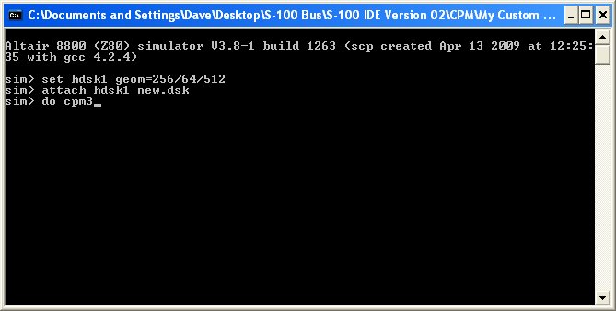

Extract the archive CPM3_LBA.ZIP to a folder on your PC hard drive
Open the folder CPMLDR, launch altairz80.exe and enter the following commands in the order shown.

set hdsk1 geom=256/64/512
attach hdsk1 new.dsk
do cpm3

At the CP/M a: prompt change to the ‘i’ drive and type the following commands allowing a little time for the submit file to run.

submit hsysgen.sub
pip j:cpmldr.com=i:cpmldr.com

The ‘J’ drive should now hold a copy of CPMLDR.COM

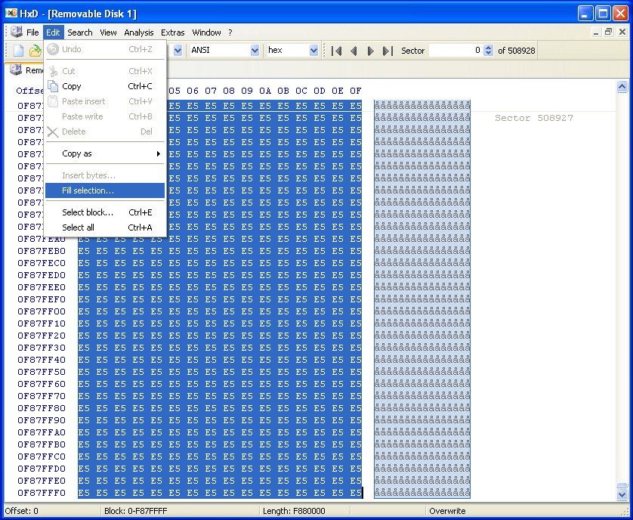

Launch HxD Hex Editor and open a compact flash card ensuring you disable read only mode

Format CF card
With the compact flash tab selected hit ctrl-A on your keyboard to highlight all bytes then select
‘Fill Selection’ from the edit menu, select the fill byte as E5 and click ok, this should change all the bytes selected to E5. Now save the changes by clicking the floppy disk icon on the toolbar.

Open our disk image
From the Extras menu select ‘open disk image’ , browse to our disk image ‘new.dsk’ in the CPMLDR folder and select open, accept the 512 byte sectors message.
This will open the disk image file in a second tab in the display, scroll through the sectors and notice how they appear to be labelled from 0 onwards at 512 byte intervals, notice also that the directory table is located at sector LBA 48 and the file cpmldr.com is located at sector LBA 112. These are both in the incorrect location for our purposes but we will correct that as we progress.

Writing CPMLDR.COM to system track
In a CHS disk setup the cpmldr.com file needs to be written to sector 1 on track 0 (0/0/1), this translates to LBA sector 0 on track 0 from what information I have gleaned over the internet and certainly this is the way I have coded the CHS to LBA translation.

Highlight the 12 sectors 112 to 123 in our disk image ‘new.dsk’ and select copy from the edit menu.
Select the tab ‘Removable disk 1’ and centre the cursor on the first byte of sector 0, go to the edit menu and select ‘paste write’, the data should now be visible starting at sector 0, hit the floppy disk icon on the toolbar and save the changes to the CF card.

Clean up the disk image ‘new.dsk’
It’s easier to progress at each stage if you have a clean disk image so highlight the first 150 sectors or so of ‘new.dsk’ and fill them with E5’s remembering to save the changes to the disk image. Now close the tab ‘new.dsk’ by right click – close.
Alternatively you can delete the current ‘new.dsk’ file and create a new copy of blank.dsk and rename it to ‘new.dsk’ so you are working with a blank disk image at each stage.

Assemble and write CPM3.SYS to CF card

Open the folder CPM3NB, launch altairz80.exe and enter the following commands in the order shown.

set hdsk1 geom=256/64/512
attach hdsk1 new.dsk
do cpm3

submit hmakecpm.sub

pip j:cpm3.sys=i:cpm3.sys

Open our disk image
From the Extras menu select ‘open disk image’ browse to our disk image ‘new.dsk’ then select open and
accept the 512 byte sectors message. Scroll through the disk image and notice again that the directory table is located at sector LBA 48 (30H) and the file cpm3.sys is located at sector LBA 112 (7FH) onwards.
Copy LBA sectors 112 - 135 from the disk image ‘new.dsk’ to the same sector numbers on the CF card anyway so that you can observe the problem.

*** Notice also that on the second line of the directory table entry we see 3 x 16 bit entries for the allocation units (AU’s) where the file cpm3.sys is stored***

00 43 50 4D 33 20 20 20 20 53 59 53 00 00 00 60 .CPM3 SYS...`
08 00 09 00 0A 00 00 00 00 00 00 00 00 00 00 00 ................

Remove the CF card from your card reader and try to boot your S100 Z80 system with it to see the effect.

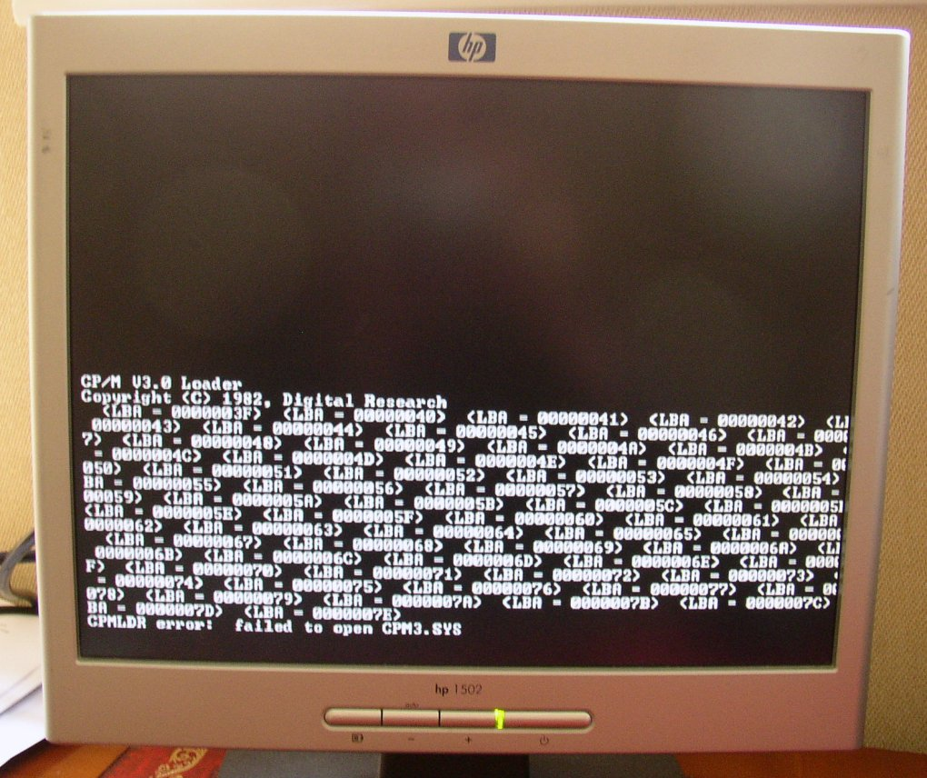

When you try to boot CP/M you will see that cpmldr.com tries to locate the directory table on what could be thought of as ‘track 1’ starting at LBA 3FH and finishing at 7EH (64 sectors) but from our copy operation above the directory table was placed at LBA 48 (LBA 30H) so it needs to be moved.

Load the CF card back into HxD Hex Editor and copy LBA sector 48 to LBA sector 63, then overwrite LBA sector 48 with E5’s and save changes. Now try to boot the CF card again to observe the next problem.

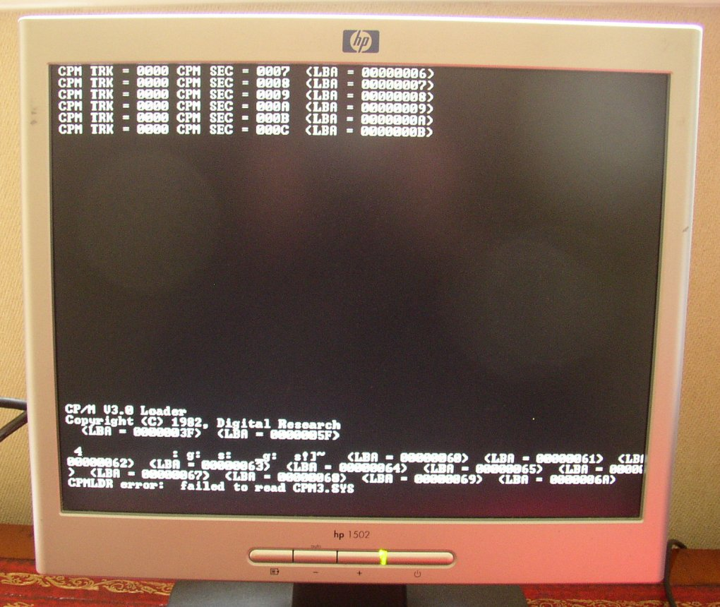

We can now see that cpmldr.com has located the directory table at LBA sector 3FH and has attempted to read the first sector of cpm3.sys at LBA sector 5FH it then turns to jibberish, so the next question is where should the file cpm3.sys be located on the CF card ?

Going back to the beginning of this section we can see that in our disk image ‘new.dsk’ the directory table was located at LBA 30H and the data started at LBA 70H, a difference of 64 sectors or 32Kbytes. When the disk image was created on the SIMH Altair we specified the disk geometry but the program chose the number of directory entries and the Allocation Unit size for us. We still need 64 sectors on our CF card for the 1024 directory entries so with the directory table now starting at LBA 3FH it should finish at LBA 7EH inclusive making the start of the program/data area LBA 7FH. With this in mind we also need to update the directory table entry for cpm3.sys with the correct AU entries, there will also be twice as many entries as our Allocation Unit size was set up as 2kB clusters (AU’s) in the CP/M bios source files and not 4kB that the Altair sim has created.

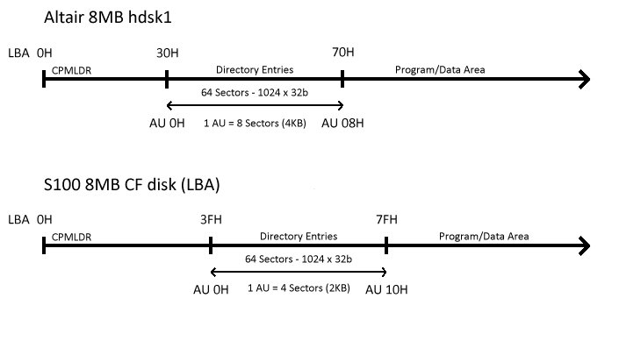

So, load the CF card back into HxD Hex Editor and copy the data LBA sectors 112 – 135 (cpm3.sys) on the CF card to LBA sectors 127 – 150 then fill LBA 112 – 126 with E5’s to tidy up, save the changes to the CF card.

We now need to update the directory table entry to reflect the new location of the file.

00 43 50 4D 33 20 20 20 20 53 59 53 00 00 00 60 .CPM3 SYS...`
10 00 11 00 12 00 13 00 14 00 15 00 00 00 00 00 ................

Referring to the diagram above we can see that the first valid allocation unit in the program/data area is 10H
So amend the entries in the directory table with sequential values starting at 10H remembering that we have twice as many entries due to the smaller cluster (AU) size.

Save the changes by clicking the floppy disk icon on the toolbar.

Now load the CF card back into the S100 system and attempt another CP/M boot.
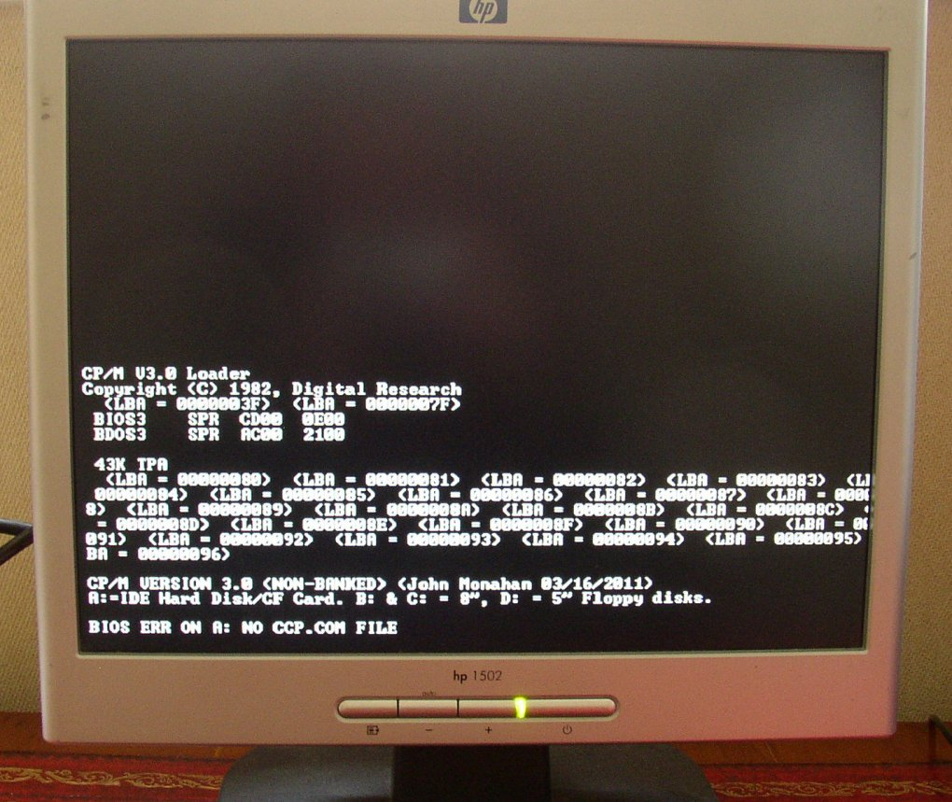

We can now see that CPMLDR.COM has loaded up and handed control over to CPM3.SYS (no more LBA sector numbers reported) which is now reporting that CCP.COM could not be found.

You now need to repeat the above process to copy CCP.COM from the SIMH Altair ‘i’ drive to a blank drive ‘j’
Using the command
pip j:CCP.COM=i:CCP.COM[R]

Place the CCP.COM file data in LBA sectors 151 – 157 on the CF card and then copy and paste the directory table entry and place it beneath the directory table entry for CPM3.SYS
The correct AU values for the CCP.SYS entry are shown below.

00 43 43 50 20 20 20 20 20 C3 CF 4D 00 00 00 19 .CCP ÃÏM....
16 00 17 00 00 00 00 00 00 00 00 00 00 00 00 00 ................

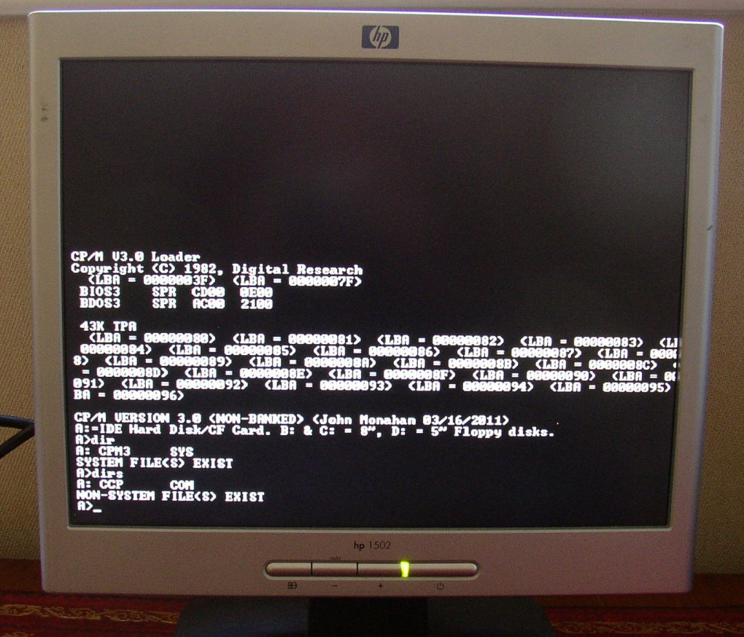

Finally the system boots to a command prompt and we can perform a DIR command to view our files.
As a final step you may want to go back to recompiling CPMLDR from the version without the LBA sector reporting to clean up the screen.

Enjoy........

